**Lab Chapter 11**

Create the following application using a class for a custom chandelier company:

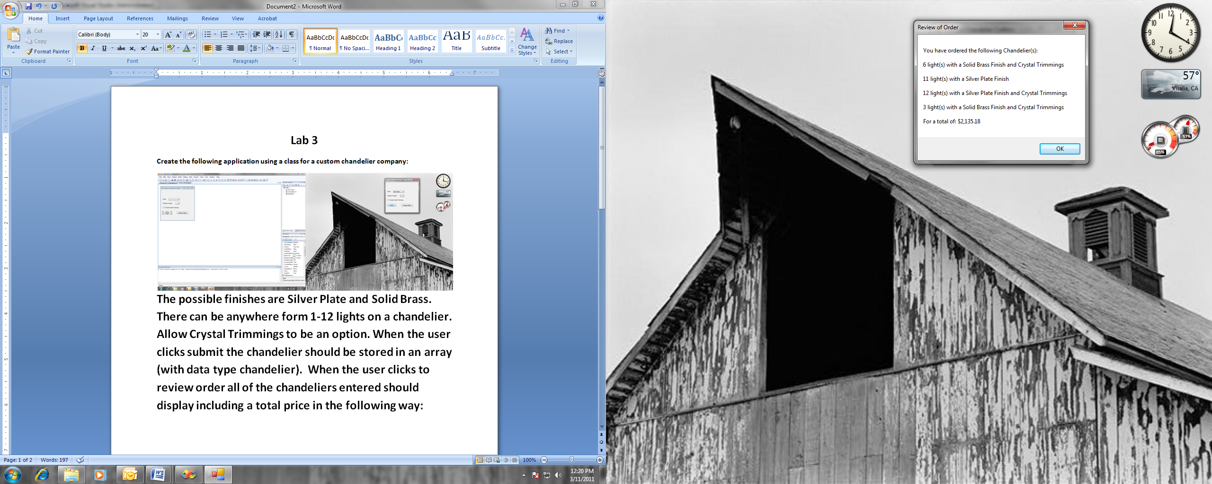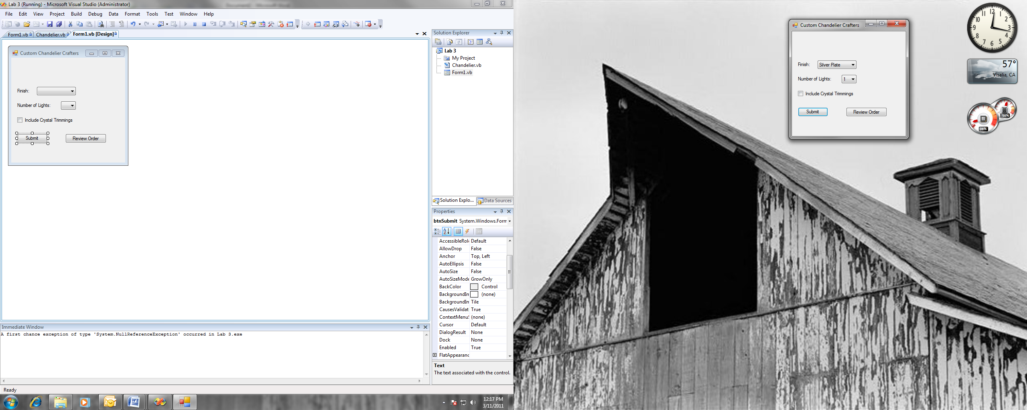

The possible finishes are Silver Plate and Solid Brass. There can be anywhere form 1-12 lights on a chandelier. Allow Crystal Trimmings to be an option. When the user clicks submit the chandelier should be stored in an array (with a data type chandelier). When the user clicks to review their order all of the chandeliers entered should display including a total price in the following way using a message box:

Notes:

1. You must use a class with a default constructor and properties for all of the variables in the class which should be declared as private. There should be a method for calculating the cost of the chandelier and a separate method that returns a Boolean value as to whether the chandelier has crystal trimmings.
2. The cost per light of a silver plate chandelier is $39.99 and for a solid brass chandelier the cost per light is $49.99.
3. Crystal trimmings cost an additional $25.50 per light regardless of the chandelier’s finish.

* Will need an array of chandeliers